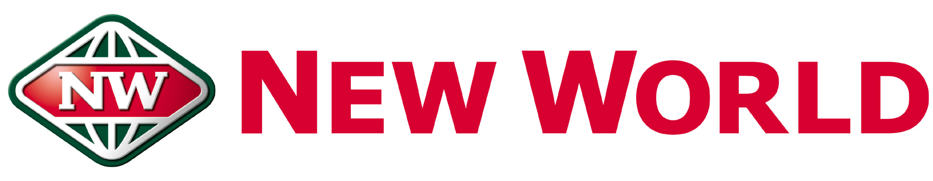

SOUTHMALL

DUTY MANAGER

We are seeking an experienced Duty Manager who has strong leadership abilities to oversee our store. Will need to have good organisational and communications skills, and will also display high presentation standards, honesty, and an excellent work ethic.

The successful applicant for this role will be responsible for ensuring that our store is always represented to the highest possible standard and effectively communicating any issues with the appropriate team members or Department Managers. They will also be responsible for solving any customer issues that may arise, making sure that team members are always productive and ensuring that the store is closed securely at the end of the night.

Due to the importance of the role the successful candidate will need to demonstrate the following qualities:
- Excellent communication and customer service skills.
- Highly motivated and be able to motivate the team.
- Understanding of Health & Safety and Food Safety.
- Intermediate level of computer literacy.
- Have a high attention to detail and be able to prioritise tasks.
- Must have valid Manager’s Certificate
- Must have Forklift licence, including F endorsed
- Committed to coming to work every shift with a positive and enthusiastic attitude.
- Excellent multi-tasking and time management skills.
- Is trustworthy and reliable.

If you are looking for an opportunity to join a team that focuses on providing great service, advancing your skills and a brighter future, then look no further.

Applicants must have NZ residency or the legal right to work in New Zealand. Shortlisted candidates will be contacted immediately. Please note that applicants are encouraged to apply as soon as possible as applications may be reviewed prior to the closing date. As such, the closing date is subject to change without notice.

