JOB DESCRIPTION
JOB TITLE | Checkout Operator / Merchandiser
STORE | Marsden Cove 4SQ
DATE | 22/11/2021
REPORTS TO | Store Owner / Store Manager
PURPOSE OF POSITION | The Checkout Operator / Merchandiser is responsible for ensuring the store is always presented in an appealing manner thereby encouraging customers to make purchases. They are also responsible for handling all customer enquiries/ complaints, serving the Customers and using their product knowledge and customer service skills to make sales and encourage repeat business.  The Checkout Operator / Merchandiser works where the business requires following the instruction of a duty manager, store manager and/or owner operator. They may be required in cleaning tasks, food preparation, assisting in deliveries, stocking shelves or on checkout.
STORE VISION | To be the first choice Supermarket for Marsden Point & Ruakaka and surrounding areas
STORE VALUES | Respect / Communication / Teamwork
REPORTING STRUCTURE
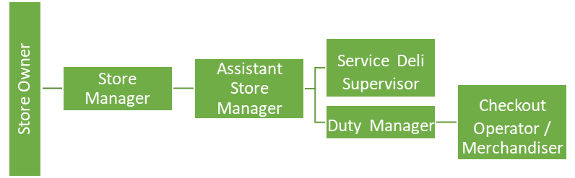
RELATIONSHIPS
INTERNAL  • Owner/Operator  • Managers  • Team members  • Foodstuffs’ support team |  | EXTERNAL  • Delivery drivers  • Customers
ACCOUNTABILITIES
OPERATIONAL | - Actively works towards helping the store deliver on the Four Square customer promises, which are Fresh Faves, Everyday Essentials and Local Service.  - Assist in all areas of the store as required  - Adhere to the food safety & health and safety policies and guidelines  - Food preparation  - Assist in ensuring deliveries are unloaded in a timely fashion  - Enhance the image of the store by implementation of agreed standards of display and presentation of stock  - Ensure the appropriate stock rotation policy is adhered to  - Ensure the aisles are kept clear of rubbish and blockages at all times allowing for clear customer access  - Process all customer orders as per company guidelines  - Complete housekeeping/ cleaning responsibilities  - Effectively resolve all customers related enquiries/ complaints when able to and escalate issues to management when required  - Follow any other reasonable instructions from managers and senior team members  - Opening and closing of our Kiosk area
COMPLIANCE | - Follow all Health and Safety Policy, Food Safety Policy and compliance procedures in the store.  - Effective use of our Safe Food Pro System for all Food safety compliance.
CULTURAL | - Contribute effectively as a team member  - Live the store values

PERSON SPECIFICATION
PEOPLE FOCUS | WORKING WITH PEOPLE  - Is self -aware, approachable and mindful of their impact on others  - Demonstrates an interest in, and understanding of people, behaving in a culturally sensitive manner  - Is outgoing and supportive; recognising and acknowledging the contribution of others  - Actively contributes to a team spirit of openness and inclusiveness where colleagues feel able to offer ideas  - Listens and communicates openly and proactively  - Adapts their style to build and maintain relationships with multiple stakeholders (other team members, suppliers, peers etc.)
CUSTOMER FOCUS | MEETING CUSTOMER EXPECTATIONS  - Brings everything back to the customer; identifying and focusing upon their needs & expectations  - Actively sets, monitors and maintains consistently high standards of customer service  - Continuously makes improvements for customers; seeking input from other team members and customers to do so  - Creates an environment that customers want to shop  - Is responsive to feedback from all sources  - Adopts a “service” mentality at all times regardless of their position or experience, genuinely enthusiastic about the difference service makes to the customer and success of the business
CO-OPERATIVE CULTURE | ADHERING TO PRINCIPLES AND VALUES  - Personally upholds ethics and Foodstuffs Values and accepting nothing less from their team  - Consistently demonstrates honesty and integrity (in words, decisions and actions) in all of their dealings with customers, other team members, suppliers, colleagues)  - Follows due process on all issues of compliance  - Demonstrates a strong work ethic through their commitment to the store’s success, ownership of problems and self-discipline  - Leads by example in terms of Foodstuffs values, drive to succeed and positive outlook  - Challenges appropriately while respecting the position of others

PERSON SPECIFICATION
ESSENTIAL | - Physically fit and able to fulfil the requirements of the role  - Good Command of written/ spoken English
DESIRED | - Good basic maths skills  - Unit standards 497, 167 & 168  - Customer service experience  - Food retail/ fresh food experience  - Previous checkout experience

SIGNATURE
I have read and understood this Job Description:

Signature Date

