
Taupō Job Description

Position Title | Online Assistant
Date | March 2025
Reports to | Online Manager and Assistant Online Manager
Position Purpose | The primary role of the Online Assistant is to ensure items picked, packed, processed is completed accurately and efficiently, within quality and policy standards.
Store Values | Purpose – Taking pride in what we do because what we do makes a difference.  Belonging – Being part of a family that respects, inspires and cares.  Growth – Challenging ourselves to learn, develop and thrive.  Empowerment – Supporting each other to do the right thing.

Reporting Structure
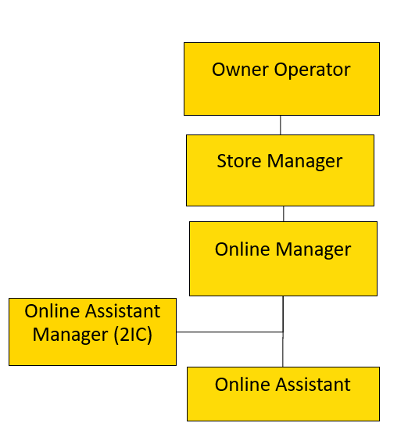

Relationships
Internal  - Owner Operator  - Store Manager  - Checkout Manager  - Assistant Checkout Manager  - Department team members  - Other store team members | External  - Customers

Accountabilities
Operational | - Ensure picking, packing, processing and invoicing a customer’s order (where applicable) is completed accurately and efficiently and that “best practice” guidelines are adhered to around best before/use-by dates, weights, restricted items and appropriate substitutions.  - Ensure the reputation of the business by promoting and championing exceptional levels of customer service to online customers.  - Effectively resolve all online customer related enquiries and complaints. Minimise customer complaints received.  - Assist the Online Manager and Assistant Manager to plan, monitor and prioritise work-flow from the start of the picking order to completion of Click ‘n Collect.  - Ensure operational delivery standards are met or exceeded including:  - Ensure pick rate, availability and good order targets are achieved  - Ensure the staging area and online equipment is clean and organised and well maintained.  - Ensure orders are labelled and checked, stored securely within the Staging Area and temperature checked within appropriate timeframes  - Ensure that all restricted goods collected by customers are ID checked as required.  - Communicate with customers to advise of out of stocks, substitutions and any other relevant information relating to their order.  - Assist in other departments when requested by Online Manager and or Online Assistant Manager. This may include the Dry, Fresh and Checkout departments.
Compliance | - Follow Health and Safety Policy, Food Safety Policy and compliance procedures in the store.
Cultural | - Contribute effectively as a team member  - Live the store values

Person Specification
People Focus | Working with People  - Is self -aware, approachable and mindful of their impact on others.  - Demonstrates an interest in, and understanding of people, behaving in a culturally sensitive manner.  - Is outgoing and supportive, recognising and acknowledging the contribution of others.  - Actively contributes to a team spirit of openness and inclusiveness where colleagues feel able to offer ideas.  - Listens and communicates openly and proactively.
Customer Focus | Meeting customer expectations  - Brings everything back to the customer, identifying and focusing upon their needs & expectations.  - Actively sets, monitors and maintains consistently high standards of customer service.  Adapting and responding to change  - Adapts to changing circumstances and accepts new ideas and initiatives.  - Tolerates ambiguity.  - Adapts personal style to suit different people and situations.  - Shows an interest in new experiences.
Co-operative Culture | Adhering to Principles and Values  - Personally upholds ethics and the store’s Values and accepting nothing less from their team.  - Consistently demonstrates honesty and integrity (in words, decisions and actions) in all their dealings with customers, staff, suppliers, colleagues).  - Follows due process on all issues of compliance.  - Demonstrates a strong work ethic through their commitment to the store’s success, ownership of problems and self-discipline.  - Leads by example in terms of Foodstuffs values, drive to succeed and positive outlook.  - Challenges appropriately while respecting the position of others.

Qualifications and Experience
Essential | - Physically fit and able to fulfil the requirements of the role.
Desired | - Good command of written and spoken English.  - Good basic maths skills.

Signature
I have read and understood this Job Description:

Employee Signature Date:

