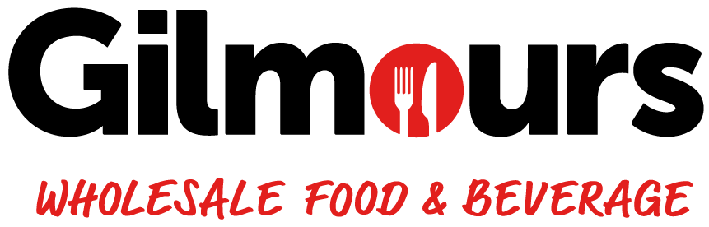
JOB DESCRIPTION
JOB TITLE | Customer Sales Support
STORE | GILMOURS TAURANGA
DATE | 2025
REPORTS TO | Commercial Manager
PURPOSE OF POSITION | To serve as the primary point of contact for customers at Gilmours Tauranga. Responsibilities include addressing internal and external customer queries in person, via email, and over the phone, which may involve tasks such as reprinting invoices, handling product inquiries, managing various other customer inquiries and issues. Additionally, this role involves driving sales growth, maximising profitability, and strengthening customer relationships by proactively managing allocated accounts and promoting Gilmours Tauranga’s products. This role also focuses on outbound sales calls, national account management, and supporting the sales team in customer retention and margin improvement.
STORE VISION | To be Tauranga’s most trusted wholesale food & beverage partner. We work hard to earn the trust of our customers. Our customers know they can rely on us to do right by them. They prefer Gilmours for the certainty in what we do, and our integrity in how we do it. We make doing business with us easy for our customers because we understand that our business is only as strong as their business. Our customers’ success is how we define our success. It’s personal for us.
STORE VALUES | Honesty - We will always communicate honestly and openly with our customers, suppliers, and each other. We will deliver on our promises with integrity.  Respect - We will be professional in our conduct with everyone, every day.  Customer Focused - Our customers are the centre of all our decisions. We will always work with them in ways that will encourage long-term relationships.  Enthusiastic - Our goal is to be acknowledged as the best place to work, and to do business with. We will always be willing to go the extra mile.  Health & Safety - Our people are healthy, live with balance and go home from work safely every day.

ACCOUNTABILITIES
OPERATIONAL | - Provide support across various functions of the role, including outbound sales calls and National Account coordination.  - Oversee the effective use of Salesforce, including investigating and resolving any issues.  - Ensure data accuracy and integrity within Salesforce by regularly updating customer information and transaction records.  - Generate and analyze Salesforce reports to support decision-making and account management.  - Manage delivery credits, returns, and queries in a timely and efficient manner to maintain customer satisfaction.  - Resolve customer-related enquiries and complaints professionally, escalating complex issues to management when required.  - Handle all inbound calls, ensuring they are responded to promptly and directed to the appropriate team.  - Respond to customer email queries related to their accounts, including invoice reprints and statement requests.  - Perform additional customer service duties as delegated by management.  - Support weekly promotional campaigns and contribute to overall membership growth strategies.  - Maintain a strong understanding of and adherence to Health & Safety responsibilities relevant to the role.  - Demonstrate professionalism and a customer-first approach in all interactions.  - Perform any ad-hoc tasks assigned by the management team.
COMPLIANCE | - Follow all Health and Safety Policy, Food Safety Policy and compliance with the policy and procedures in the store
CULTURAL | - Understand that Gilmours Tauranga is a food and beverage distribution company focused on buying and selling, not manufacturing. As a marketing-driven company, all staff members must embrace their roles as salespeople.  - Recognize that our customers are the most crucial part of our business. Without them, we have no sales, no turnover, no profit, no jobs, and no wages. It is essential to always provide excellent service and care to all customers, whether they are small or major clients, as they are all valuable to our success.  - Ensure all activities and practices align with the Gilmours values and contribute to a positive workplace culture.  - Contribute to overall continual improvement strategy by actively helping to resolve any customer service issues that arise  - Contribute effectively as a team member  - Maintain and develop exceptional internal relationships with co-workers

ATTRIBUTES
PEOPLE FOCUS | WORKING WITH PEOPLE  - Is self -aware, approachable and mindful of their impact on others  - Demonstrates an interest in, and understanding of people, behaving in a culturally sensitive manner  - Is outgoing and supportive; recognising and acknowledging the contribution of others  - Actively contributes to a team spirit of openness and inclusiveness where colleagues feel able to offer ideas  - Listens and communicates openly and proactively  - Adapts their style to build and maintain relationships with multiple stakeholders (other team members, suppliers, peers etc.)  PERSUADING AND INFLUENCING  - Makes a strong, positive personal impression on others.  - Gains clear agreement and commitment from clients through persuasion and negotiation.  - Inspires and convinces clients, giving them the confidence to choose our products and services.  - Facilitates discussions to ensure all client needs and ideas are heard, influencing outcomes and actions.  - Manages conflict with clients openly, fairly, and quickly.  - Uses questioning and listening skills to understand client issues and collaboratively create solutions.  - Demonstrates resilience by encouraging clients to try new products and services despite setbacks.  - Embraces new ideas and initiatives, adapting to changing market circumstances.  - Shares knowledge and expertise to support the team and clients.
CUSTOMER FOCUS | MEETING CUSTOMER EXPECTATIONS  - Brings everything back to the customer; identifying and focusing upon their needs & expectations  - Actively sets, monitors and maintains consistently high standards of customer service  - Continuously makes improvements for customers; seeking input from other team members and customers to do so  - Creates an environment that customers want to shop  - Is responsive to feedback from all sources  - Adopts a “service” mentality at all times regardless of their position or experience, genuinely enthusiastic about the difference service makes to the customer and success of the business
CO-OPERATIVE CULTURE | ADHERING TO PRINCIPLES AND VALUES  - Personally upholds ethics and Gilmours Tauranga Values and accepting nothing less from their team  - Consistently demonstrates honesty and integrity (in words, decisions and actions) in all of their dealings with customers, other team members, suppliers, colleagues)  - Follows due process on all issues of compliance  - Demonstrates a strong work ethic through their commitment to the store’s success, ownership of problems and self-discipline  - Leads by example in terms of Gilmours Tauranga values, drive to succeed and positive outlook  - Challenges appropriately while respecting the position of others

REPORTING STRUCTURE
Store Owner / Operator

Commercial Manager

Customer Service Support

RELATIONSHIPS
INTERNAL  • Owner/Operator  • Commercial Manager  - Managers  • Other Gilmours team members  • Foodstuffs’ support team | EXTERNAL  • Customer  - Suppliers

QUALIFICATIONS AND EXPERIENCE
ESSENTIAL | - Physically fit and able to fulfil the requirements of the role  - Superb Command of written/ spoken English  - Proven customer service experience and skill  - Relationship building/ diplomacy skill  - Strong analytical skill  - CRM Proficiency  - NCEA Level 3
DESIRED | - Good basic maths skills  - NCEA Level 4, 5, 6 or 7  - Unit standards 497, 167 & 168  - Customer service experience  - Previous retail or wholesale experience

SIGNATURE
I have read and understood this Job Description:

Signature Date

