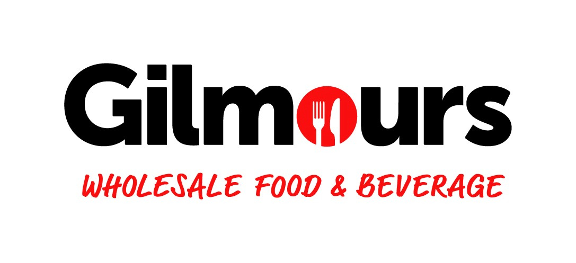
Chilled/Produce Assistant
Position
Printed 01/07/25
POSITION NAME | Chilled/Produce Assistant
RESPONSIBLE TO | Chilled/Produce Department Manager
LOCATION | Gilmours Mt Roskill
PURPOSE | This role is to support the smooth running of the Chilled/Produce departments by managing replenishment tasks, rotating and locating stock correctly, maintaining clean and organized areas, monitoring stock discrepancies, and contributing to efficient daily store operations all while contributing to a great customer experience.
QUALIFICATIONS | ESSENTIAL  - 3-4 years Secondary Education.  - Retail / Wholesale Experience to Supervisory Level.  - 2-3 years prior Warehouse / Replenishment Experience.  - Hoist (not necessary but would be of advantage)  - Reach (not necessary but would be of advantage)  - Racking & Stacking
TRAINING REQUIRED | Pallet Jacks, Safety Knives, Store opening, racking and stacking, FCP, Safety Leadership, OOS, WMS training as required

Key Relationships
INTERNAL | COMMITTEES & GROUPS
- Owner Operator  - Store Manager  - Outbound Manager  - Department Managers  - Stock Controllers  - Replenishment Team Members  - Other Store Staff | - Duty Managers  - Health and Safety Committee

Accountabilities

KEY TASK AREAS
- Ensure all stock is efficiently located in the appropriate shelf/location in a timely manner as directed by the Chilled Department Manager
- Ensure stock required is replenished into assigned areas from inwards and other locations eg full case locations.
- Ensure appropriate rotation of stock on the shelf and if placing stock in back or other locations.
- Ownership, replenishment of an assigned department
- Ensure all areas of the store are clean and tidy at the end of identified shifts.
- Ensure MHE you are using is maintained, safe and on charging station at the end of identified shifts
- Trouble shoot or coordinate on any pricing discrepancies with staff/customers and ensure these are dealt with in the shortest time possible
- Merchandising and store presentation that delivers and exceeds our customer needs.
- Assist in seasonal change overs of stock eg Xmas, Easter, Monthly promotions
- Replace data strips as required.
- Replace price tickets as required.
- Assist Replenishment team as required.
- Empty Rubbish/Cardboard/Plastic bins as required.

OPERATIONAL
- Maintaining drop list so stock is always available for put away and also maintaining back locations and source bin.
- Maintain and enhance good customer relations ensuring that customer complaints are dealt with in a manner that satisfies the customer within the boundaries of store policy and interaction with reps and manufacturers meets a high standard of professionalism.
- Be informed of and provide feedback on all Stock Management policies and procedures when required. Accessing the required training and experience to perform the necessary operations. Be available to staff to assist warehouse operations staff and make decisions. Communicate to the supervisor/manager all matters which require attention or further action.
- Contributes to the effective co-operation within the store and maintains a focus on continuous improvement.
- Follow standard operating procedures and assist other team members as required.
- Observes and conforms to required levels of health and safety standards in day-to-day operation.
- Be available to help with other tasks in the operation as they come up

KPIS
- Adhere to FIFO store rotation.
- Manage daily check-ups on a daily basis.
- Comply with store standards.
- Staff engagement levels

Key Competencies

CULTURAL

- Contribute effectively as a member of the Gilmours team
- Contribute, mentor a culture of ‘Continuous Improvement’ within the business
- Ensures effective interaction and relationship with wider Gilmours team members, Foodstuffs, and other staff by living the Gilmours Values and agreeing personal accountabilities.
- Team culture is in keeping with Company values

SPECIFIC SKILLS / ATTRIBUTES

- Flexibility to work all days of the week. Customer & Results Focused.
- Can work in a Chilled Environment
- Proven ability to deal with people of all cultures / races.
- Strong Relationship Builder, Team Player and Problem Solver.
- Strong communication (verbal and written), relationship management, negotiation and networking skills.
- Coaching and Mentoring.
- Planning and organising & Time Management skills.
- Maintaining Standards and Eye for Detail.
- Physically fit and healthy.

Manager Employee
Signed : _______________________ Date : ___________ Signed : _______________________ Date : ___________

