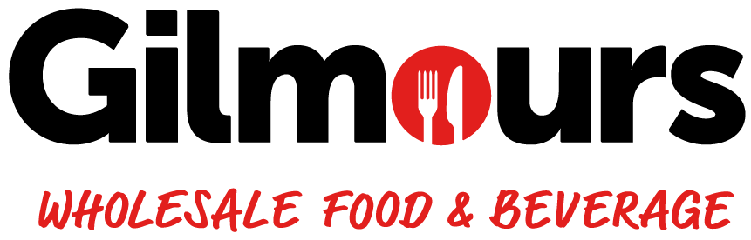
JOB DESCRIPTION
JOB TITLE | Warehouse Team Member
STORE | GILMOURS TAURANGA
DATE
REPORTS TO | Service Manager/ Shift Supervisor
PURPOSE OF POSITION | To ensure efficient and accurately picking and packing of customer orders, secure loading onto delivery vehicles, and proper replenishment of shelves. This role is vital for maintaining smooth warehouse operations, accurate stock levels, and timely service to customers.
STORE MISSION | To be Tauranga’s most trusted wholesale food & beverage partner. We work hard to earn the trust of our customers. Our customers know they can rely on us to do right by them. They prefer Gilmours for the certainty in what we do, and our integrity in how we do it. We make doing business with us easy for our customers because we understand that our business is only as strong as their business. Our customers’ success is how we define our success. It’s personal for us.
STORE VALUES | Honesty - We will always communicate honestly and openly with our customers, suppliers, and each other. We will deliver on our promises with integrity.  Respect - We will be professional in our conduct with everyone, every day.  Customer Focused - Our customers are the centre of all our decisions. We will always work with them in ways that will encourage long-term relationships.  Enthusiastic - Our goal is to be acknowledged as the best place to work, and to do business with. We will always be willing to go the extra mile.  Health & Safety - Our people are healthy, live with balance and go home from work safely every day.

ACCOUNTABILITIES
OPERATIONAL | - Accurately pick, pack, fixit and dispatch stock as required, ensuring appropriate service level and KPI’s are met  - Assist in all areas of the store as required  - Adhere to the food safety & health and safety policies and guidelines  - Assist in ensuring deliveries are loaded as required  - Bring stock required to replenish assigned areas from inwards and other locations  - Ensure a minimum level of disruption to customers while replenishing stock  - Prioritize replenishment focusing on promotional lines and out-of-stock items.  - Enhance the image of the store by implementation of agreed standards of display and presentation of stock  - Ensure the appropriate stock rotation policy is adhered to  - Ensure the aisles are kept clear of rubbish and blockages at all times allowing for clear customer access  - Complete housekeeping/ cleaning responsibilities  - Monitor security of the warehouse at all times  - Monitor impulse bars, promotional displays, and fridges in the checkout area, ensuring correct pricing and ticketing  - Maintain safety standards, using appropriate safety equipment and signage as required.  - Report major breakages or spillages to the Manager/Supervisor promptly.  - Note and escalate out-of-stock and over-stock issues, liaising effectively with the Manager/Supervisor.  - Assist in resolving stock or count data-related issues.  - Ensure credits are handled appropriately and assist with stock takes as required.  - Complete required training and follow health and safety and food safety policies to agreed standards.  - Ensure the security of stock, personnel, and equipment at all times.  - Demonstrates the ability to navigate the WMS including tasks accurately and efficiently such as order processing, real-time product and order tracking, and managing warehouse transfers.  - Ensures compliance with key procedures such as proper barcode scanning, accurate data entry, maintaining stock location accuracy, and timely updates to inventory levels to prevent discrepancies.  - Perform any ad-hoc tasks as directed.
COMPLIANCE | - Follow all Health and Safety Policy, Food Safety Policy and compliance procedures in the store
CULTURAL | - Follow any other reasonable instructions from managers and senior team members  - Contribute effectively as a team member  - Live the store values

ATTRIBUTES
PEOPLE FOCUS | WORKING WITH PEOPLE  - Is self-aware, approachable, and mindful of their impact on others  - Demonstrates an interest in, and understanding of people, behaving in a culturally sensitive manner  - Is outgoing and supportive, recognising and acknowledging the contribution of others  - Actively contributes to a team spirit of openness and inclusiveness where colleagues feel able to offer ideas  - Listens and communicates openly and proactively  - Adapts their style to build and maintain relationships with multiple stakeholders (other team members, suppliers, peers etc.)
CUSTOMER FOCUS | MEETING CUSTOMER EXPECTATIONS  - Brings everything back to the customer; identifying and focusing upon their needs & expectations  - Actively sets, monitors and maintains consistently high standards of customer service  - Continuously makes improvements for customers; seeking input from other team members and customers to do so  - Creates an environment that customers want to shop  - Is responsive to feedback from all sources  - Adopts a “service” mentality at all times regardless of their position or experience, genuinely enthusiastic about the difference service makes to the customer and success of the business
CO-OPERATIVE CULTURE | ADHERING TO PRINCIPLES AND VALUES  - Personally upholds ethics and Gilmours Tauranga Values and accepting nothing less from their team  - Consistently demonstrates honesty and integrity (in words, decisions and actions) in all of their dealings with customers, other team members, suppliers, colleagues)  - Follows due process on all issues of compliance  - Demonstrates a strong work ethic through their commitment to the store’s success, ownership of problems and self-discipline  - Leads by example in terms of Gilmours Tauranga values, drive to succeed and positive outlook  - Challenges appropriately while respecting the position of others

REPORTING STRUCTURE
Store Owner / Operator

Store Manager

Service Manager

Shift Supervisor
Warehouse Team Member

RELATIONSHIPS
INTERNAL  • Owner/Operator  • Managers  • Other Gilmours team members  • Foodstuffs’ employees | EXTERNAL  • Delivery drivers  • Customer  - Suppliers

QUALIFICATIONS AND EXPERIENCE
ESSENTIAL | - Physically fit and able to fulfil the requirements of the role  - Good Command of written/ spoken English  - NCEA Level 2 or 3
DESIRED | - Forklift Licence and experience operating forklift  - Good basic maths skills  - Unit standards 497, 167 & 168  - Customer service experience  - Previous retail, wholesale or FMCG experience

SIGNATURE
I have read and understood this Job Description:

Signature Date

