
Merchandising Assistant Manager Job Description

Reports to Merchandising Manager
Purpose of the Merchandising Assistant Manager Role
To assist the Merchandising Manager in the day to day running of the department and all team members. This includes helping to achieve financial targets and to ensure all operational and cultural standards are maintained at all times. To stand in for the Department Manager in their absence.
Main Responsibilities
Operational:
- Assist in the day to day running of the department.
- Contribute effectively as a member of the management team.
- Customer-focused, all interactions dealt with in a timely and professional manner.
- Create relationships with all relevant company reps/merchandisers.
- Maintain Health and Safety and Food Safety compliance.
- Check all equipment and fixtures/fittings are in safe working order, and report any issues.
- Assist in ensuring the department has the best quality products which are displayed and maintained to the highest standard at all times.
- Maintain price integrity at all times, ensuring POS and tickets prices match. Ensure all promotional and advertised pricing is adhered to at all times.
- Ensure all paperwork is completed on time, accurately and delivered to the right person.
- Stocktaking and ordering is accurate and completed in a timely manner.
- Ensure all team members understand and are involved in the department objectives and goals.
Financial:
- Manage credits.
- Work with the Buyer to ensure sales and GP targets are achieved/exceeded for the year.
- Wages costs are controlled appropriately, to ensure roster is adequately staffed and holiday/Lieu days are managed to an acceptable level when the manager is away from the department.
- Help monitor sales and create opportunities to increase on the previous year.
Compliance:
- Follow Health and Safety Policy, Food Safety Policy and Compliance Procedures in the store.
- Ensure Food Safety standards are maintained through completion of appropriate daily, weekly and monthly cleaning.
- Report any compliance challenges to the Manager.
- Follow process on back to work injury management.

Cultural:
- Contribute and support the store and other departments.
- Ensure all team members have a clear understanding of their responsibilities and that they are working to all store standards, mission and values.
- Support and display the store mission and its seven values in every aspect of the role.
- Help train and develop every team members so they are all working to the best of their ability.
- Assist in conducting regular reviews with all team members.
- Have input into the recruitment of future team members.
- Promote opportunities for team members i.e. apprenticeship programmes.
Health & Safety:
- Demonstrate leadership in health & safety issues in accordance with company policies and procedures.
- Assist the department manager in managing the health, safety and welfare of department team members, including advising and training new team members and keeping all team members updated on health & safety matters.
- Ensure team members comply with company health & safety policy and procedures.
- Ensure all accidents, near misses and potential hazards within department are recorded and reported in line with company policy and procedures.
- Assist with ensuring `all equipment used within the department is maintained and safe to use, and that team members receive appropriate training in use of equipment.
- Contribute to the promotion and maintenance of safe and healthy working conditions and practices across the store, including for staff, visitors and customers.
- Liaise with the management team on health & safety matters including policy, training, hazards, accidents, near misses, investigations and actions taken.
Food Safety:
- Implement and maintain the company’s Food Safety Policy including day to day monitoring, purchasing, audits, corrective actions, etc. as required, and ensure team members adhere to Food Safety Policy requirements.
- Ensure all checks, records and documentation pertaining to food safety are completed as required.
- Support the Senior Management Team and Compliance Manager to ensure robust management of the Food Safety Policy.
- Contribute to the recall and withdrawal from sale of unsafe food as communicated by the Senior Management Team or Compliance Manager.
- Assist with ensuring all team members in department are trained in food safety as required, and that training is up to date.
- Ensure safe food is sold from own department where appropriate.

You will have a review every 6 months with the Merchandising Manager to discuss and measure how you are going with your performance.

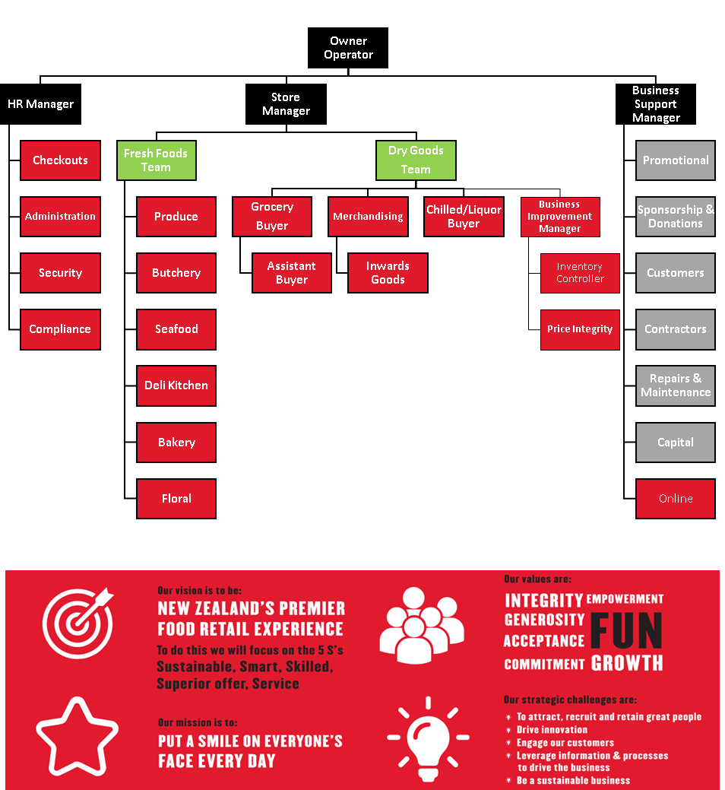
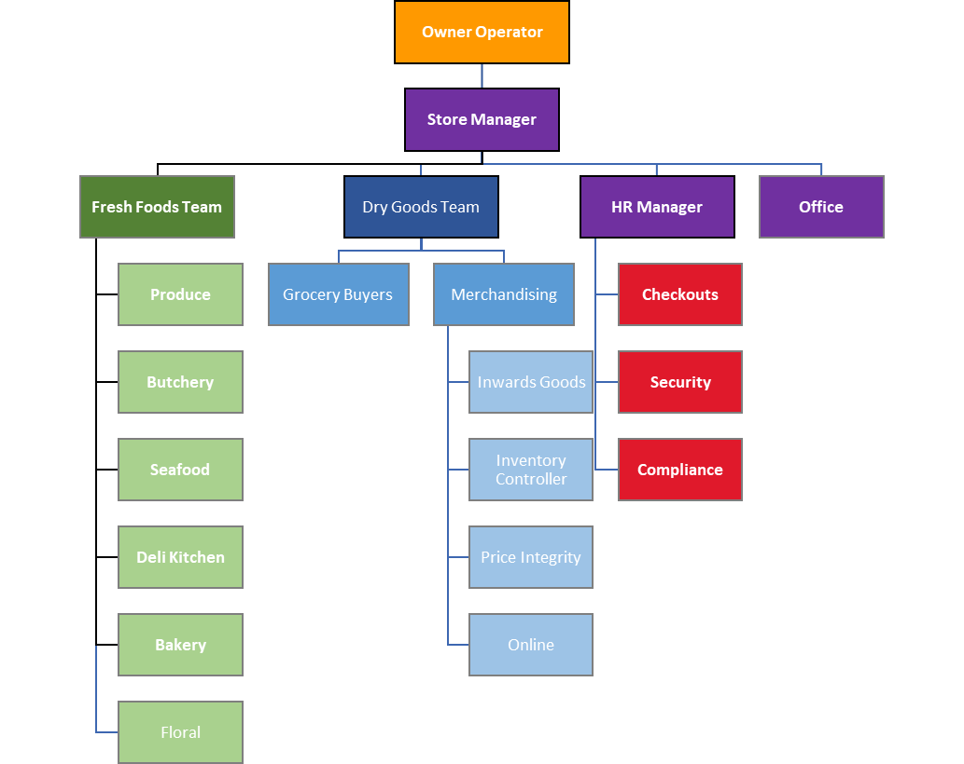
Organisational Structure

