
Inwards Goods Assistant Job Description

Reports to the Inwards Goods Team Leader Manager
Purpose of the Inwards Goods Assistant Role:
Ensuring all goods coming into the store are accounted for accurately and stored promptly and safely so that the storeroom and merchandising functions can both operate effectively and efficiently. They will also be required to work in other departments of the store when needed.
Main Responsibilities:
Operational:
- Ensure all stock is efficiently unloaded in a timely fashion and ensuring healthy and safety standards are met.
- To help manage and control the breaking down of all orders and the marking off of all stock in a timely fashion
- To help manage the storage of stock in correct locations ensuring ease of picking and replenishment.
- To help coordinate and communicate department deliveries as they arrive while maintaining compliance to coolchain and food safety guidelines
- Maintain the security of the rear door as per company guidelines
- Ensure the storeroom is kept clean and tidy at all times and that the operation of vehicles and equipment is safe and compliant to health and safety guidelines
- Is customer focused at all times so that all interactions are dealt with in a timely and professional manner.
- Creates relationships with all relevant company reps/merchandisers to maximise supplier support
- Maintains Health and Safety and Food Safety compliance
- Check all equipment and fixtures/fittings are in safe working order, and report any issues.
- Ensures all paperwork is completed on time, accurate and delivered to the right person.

Cultural:
- Contribute and support the store and other departments
- Support and display the store mission, vision and its four values in every aspect of the role.

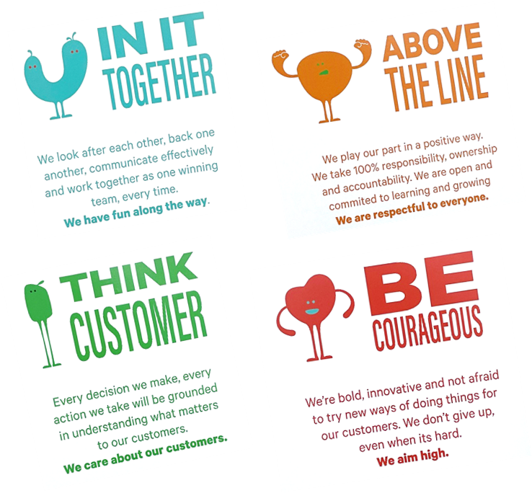
OUR VALUES

You will have a review every 6 months with the Inwards Goods Team Leader to discuss how you are going and that you are maintaining expectations.
Organisational Structure
