
Compliance Manager Job Description
Reports to the HR Manager
Purpose of the Compliance Manager Role:
Is directly responsible for ensuring that the store meets compliance requirements in Health and Safety, Food Safety and all relevant regulations.
Main Responsibilities:
Food Safety
- Implement, monitor, and enforce food safety policies, procedures, and legislative requirements.
- Conduct internal audits and coordinate internal/external food safety audits.
- Maintain compliance with Safe Food Pro, weights and measures, and food safety standards.
- Lead food safety training, meetings, and promote a strong food safety culture.
- Investigate customer complaints, product recalls, and implement corrective actions.
- Communicate food safety updates and ensure compliance across all departments.
- Follow the Food Control Plan Manual.

Health & Safety
- Develop, maintain, and improve health and safety systems, policies, and compliance.
- Conduct workplace inspections, hazard reviews, and maintain the Hazard & Risk Register.
- Investigate accidents, incidents, and near misses, ensuring corrective actions are completed.
- Chair Health & Safety Committee meetings and provide regular reporting.
- Promote a positive Health, Safety, and Wellbeing culture through training and communication.
- Liaise with regulatory bodies and report serious incidents as required.
- Follow the Health and Wellbeing and Fuel Site Manual.

Compliance & Operations
- Ensure compliance with all relevant legislation, certifications, and licensing requirements, including Liquor Licence and Building Warrant of Fitness.
- Coordinate required training, certifications, and compliance programmes.
- Work with management to ensure equipment, machinery, contractors, and service providers meet compliance standards.
- Manage product recalls, GS1 notifications, and regulatory communications.
- Maintain accurate compliance records and communicate updates to the wider team.

Leadership & Culture
- Support the Store Manager and department leaders in achieving compliance objectives.
- Foster a culture of accountability, safety, and continuous improvement.
- Build positive relationships with internal teams, external partners, and regulatory agencies.
- Support staff development through coaching, training, and collaboration with HR.

Skill Requirements:
- High level of computer literacy
- 3- 5 years retail experience
- 1 -3 years’ experience food safety and health and safety experience
- High attention to detail
- HACCP Training
- First Aid Certification
Key Attributes:
- Ability to lead and influence
- Excellent verbal and written communication skills
- Physically fit to perform task requirements
All of the above responsibilities are measured in a performance review and the store yearly audit process. You will have a review every 6 months with the HR Manager to discuss how you are going.
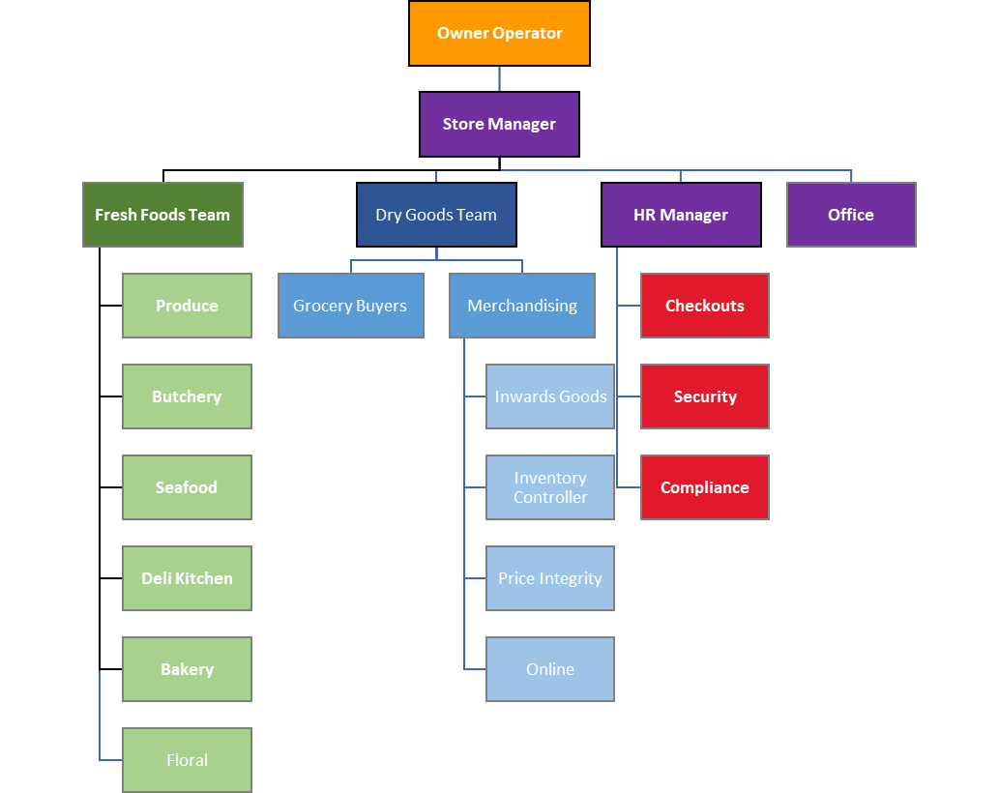
Organisational Structure

