
Merchandising 2IC Manager Job Description

Reports to Merchandising Manager
Purpose of the Merchandising 2IC Manager Role
The Merchandising 2IC Manager supports the Merchandising Manager with the day-to-day leadership and operation of the department. The role is responsible for supporting the achievement of financial and operational targets, maintaining high standards across the department, and ensuring company policies, procedures, and values are consistently upheld.
The Merchandising 2IC Manager will provide leadership and management support to the department and will assume responsibility for the department in the Merchandising Manager’s absence.
Main Responsibilities
Operational:
- Support the Merchandising Manager with the day-to-day operation and leadership of the department.
- Contribute effectively as a member of the wider management team and support the overall success of the store.
- Maintain a strong customer focus, ensuring all customer interactions and enquiries are handled promptly, professionally, and effectively.
- Build and maintain positive working relationships with relevant company representatives, suppliers, and merchandisers.
- Maintain high standards of Health & Safety and Food Safety compliance within the department.
- Regularly check equipment, fixtures, and fittings to ensure they are safe and in good working order, and promptly report any issues.
- Support the department in maintaining a strong product range, ensuring products are of the highest quality and presented and maintained to the required standards.
- Maintain accurate pricing and price integrity at all times, ensuring POS, shelf tickets, and promotional pricing are correct and aligned.
- Ensure all promotional and advertised pricing is implemented accurately and consistently.
- Ensure stocktaking and ordering processes are accurate, timely, and completed to the required standard.
- Ensure all team members understand the department’s objectives and goals and are encouraged to contribute towards achieving them.
- Provide leadership and direction to team members, ensuring departmental standards and expectations are consistently maintained.
- Take responsibility for the department in the absence of the Merchandising Manager.
Financial:
- Manage credits.
- Work with the Buyer to ensure sales and GP targets are achieved/exceeded for the year.
- Wages costs are controlled appropriately, to ensure roster is adequately staffed and holiday/Lieu days are managed to an acceptable level when the manager is away from the department.
- Help monitor sales and create opportunities to increase on the previous year.
Compliance:
- Follow and uphold all company Health & Safety, Food Safety, and compliance policies and procedures.
- Ensure Safe Food Pro requirements are completed accurately and on time on a daily, weekly, and monthly basis.
- Ensure Food Safety standards are maintained through the completion of all required daily, weekly, and monthly cleaning and hygiene tasks.
- Identify and report compliance issues or concerns to the Merchandising Manager and take appropriate corrective action where required.
- Follow company procedures for the management of workplace injuries and return-to-work processes.

Cultural:
- Contribute and support the store and other departments.
- Ensure all team members have a clear understanding of their responsibilities and that they are working to all store standards, mission and values.
- Support and display the store mission and its seven values in every aspect of the role.
- Help train and develop every team members so they are all working to the best of their ability.
- Assist in conducting regular reviews with all team members.
- Have input into the recruitment of future team members.
- Promote opportunities for team members i.e. apprenticeship programmes.
Health & Safety:
- Demonstrate leadership in health & safety issues in accordance with company policies and procedures.
- Assist the department manager in managing the health, safety and welfare of department team members, including advising and training new team members and keeping all team members updated on health & safety matters.
- Ensure team members comply with company health & safety policy and procedures.
- Ensure all accidents, near misses and potential hazards within department are recorded and reported in line with company policy and procedures.
- Assist with ensuring `all equipment used within the department is maintained and safe to use, and that team members receive appropriate training in use of equipment.
- Contribute to the promotion and maintenance of safe and healthy working conditions and practices across the store, including for staff, visitors and customers.
- Liaise with the management team on health & safety matters including policy, training, hazards, accidents, near misses, investigations and actions taken.
Food Safety:
- Implement and maintain the company’s Food Safety Policy including day to day monitoring, purchasing, audits, corrective actions, etc. as required, and ensure team members adhere to Food Safety Policy requirements.
- Ensure all checks, records and documentation pertaining to food safety are completed as required.
- Support the Senior Management Team and Compliance Manager to ensure robust management of the Food Safety Policy.
- Contribute to the recall and withdrawal from sale of unsafe food as communicated by the Senior Management Team or Compliance Manager.
- Assist with ensuring all team members in department are trained in food safety as required, and that training is up to date.
- Ensure safe food is sold from own department where appropriate.

You will have a review every 6 months with the Merchandising Manager to discuss and measure how you are going with your performance.

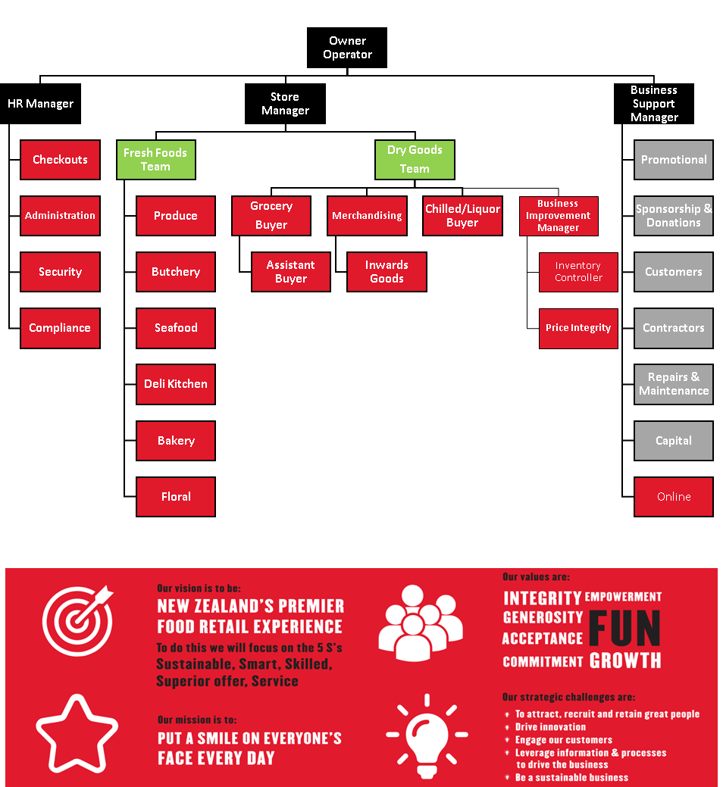
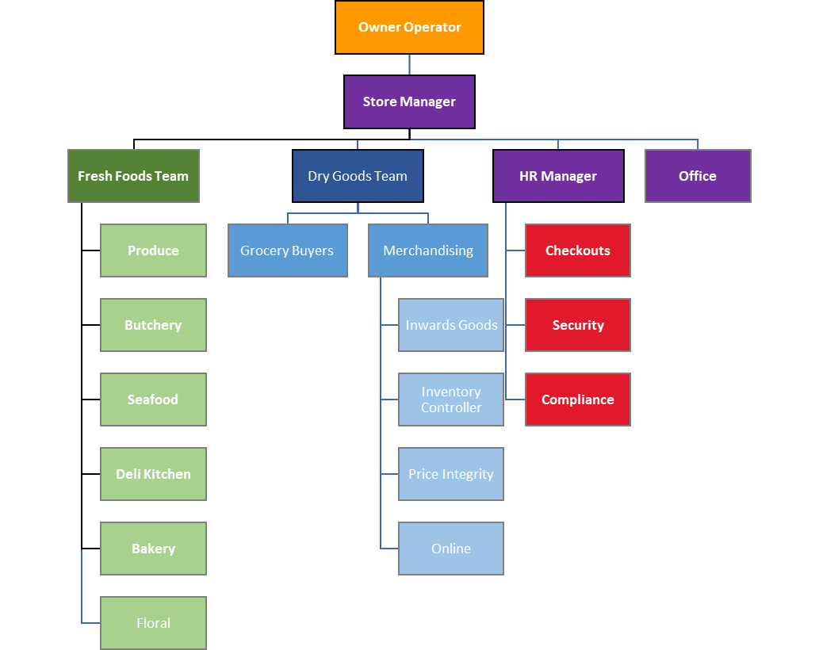
Organisational Structure

