
Florist Job Description

Reports to Floral Manager
Purpose of the Florist Role:
Is to be jointly responsible for the Floral Department. This includes managing all Financial, Operational and Cultural areas of the Floral department.
Main Responsibilities:
Operational:
- Is jointly responsible for the day to day running of the Floral Department.
- Is customer focused at all times such that all interactions are dealt with in a timely and professional manner.
- Creates relationships with all relevant company reps/merchandisers.
- Maintains Health and Safety compliance.
- Check all equipment and fixtures/fittings are in safe working order, and report any issues.
- Ensure that the department has the highest quality products displayed and maintained to the highest standard at all times so as to maximise customer satisfaction
- Drive innovation of product range so as to maximise customer satisfaction
- Enhance expertise and engagement of Floral team so as to maximise customer satisfaction
- Maintain price integrity at all times, ensuring POS and tickets prices match. Ensure all promotional and advertised pricing is adhered to at all times.
- Ensures all paperwork is completed on time, accurate and delivered to the right person.
- Stocktaking and ordering is accurate and completed in a timely manner.
- Ensures all team members understand and are involved in the department objectives and goals.
Financial:
- Manage, record and report credits
- Ensure sales, GP and profit targets are achieved/exceeded for the year
- Ensure wage costs are controlled appropriately, ensure roster is adequately staffed and holiday/lieu days are managed to an acceptable level.
- Monitor sales and create opportunities to increase on previous levels
- Manage, record and report wastage accurately and actively reduce where possible.
- Manage price perception to maximise customer satisfaction
Cultural:
- Contribute and support the store and other departments
- To support and display the store mission and its seven values in every aspect of the role.
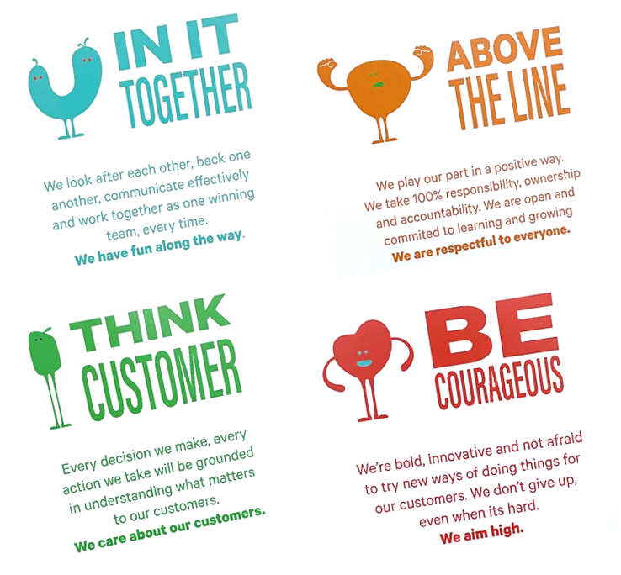
OUR VALUES

All of the above responsibilities are measured against annual performance objectives. You will have a review every 6 months with the Business Support Manager to discuss how you are going with these.

Organisational Structure
